INSURANCE DATA ANALYTICS REPORT
FOR
HEXAGON TECH HUB

BY
EBUBECHUKWU OGBONNA, Data Analytics intern

EXECUTIVE SUMMARY
This report delivers an evaluation of the auto insurance portfolio, analyzing 37.54K policyholders and $1.90B in total historical claims to optimize pricing models and accelerate targeted customer retention. While overall claim frequency remains remarkably baseline across standard demographics (~0.50–0.52 claims/policyholder), the portfolio’s financial exposure is heavily driven by distinct severity risks and customer segment behaviors:
- Low Frequency Volatility vs. High Severity Risk: While claim likelihood is evenly distributed, claim severity fluctuates drastically based on vehicle usage, education level, household income, and youth driver presence.
- High-Value Core Customer Anchor: Over 75% of policyholders (28K drivers) represent a highly profitable, low-risk foundation (Household Income > $75K, Claims ≤ 1). Protecting and retaining this primary revenue engine is critical to long-term portfolio margins.
- Commercial & Youth Driver Exposure: The portfolio's highest financial liability stems from commercial vehicle policies in households with children driving, generating severe claim spikes ($110K+ per claim event).
To maximize profitability, the business should immediately implement risk-adjusted surcharges on commercial youth policies while deploying uniform, cross-regional retention campaigns for the core high-income segment.

Core Key Performance Indicators (KPIs)
Total Policyholders: 37.54K unique policyholders.
Total Claim Amount: $1.9 Billion total claims paid.
Average Claim Frequency: 0.51 claims per policyholder.
Average Claim Amount: $50.03K per policyholder.
Claim Likelihood Rate: 27.54% overall portfolio risk likelihood.
Claim Severity Rate: $98.04K average cost per claim event.
High-Value Target Segment: 28K policyholders (75.21% of the total customer base).

SECTION 1: DATA CLEANING & METHODOLOGY
To ensure data integrity prior to analysis, the raw dataset underwent structured transformations:
- Key Uniqueness & Duplicates: A minor ID duplication anomaly (~0.1%) was identified. Investigation confirmed these were distinct individuals sharing assigned IDs. A composite primary key (`unique_policyholder_ID`) was created by adding joining ID and birthdate column to ensure proper demographic grouping without dropping valid policy records.
- Feature Engineering: `Age`, `Vehicle Age` columns were calculated and added to the table using the `birthdate` and `car_year` columns.
- Demographic Binnings: The following columns were created to categorise large range of descriptive data.
  - Ages: Grouped into `18–25`, `26–40`, `41–60`, and `60+`.
  - Vehicle ages: Grouped into `13–15 (Newer models)`, `16–20 (Mid-Age)`, `21–25 (Older)`, and `26+ (Vintage/Older)`.
  - Income group: Grouped into `Mid($30-75k)`, `High($75-120k)` and `Very High(>$120k)`
  - Is target customer: Grouped into `Target (High-Income & Low-Risk)` and `Other`.
- Explicit DAX Measures: Standardized base aggregations (`Total Claim Amount`, `Total Policyholders`) into explicit DAX measures to calculate compound risk ratios like `Claim Severity Rate` ($\frac{Total Claim Amount }{Total Claim Frequency}$) and `Claim Likelihood Rate` ($\frac{Count of ID with Claim Freq>0 }{Total Policyholders}$)
Note: Total Claim Amount ($1.9B) reflects lifetime historical payouts across the customer base, while current-period active claims account for ~$500M+. For overall portfolio analysis, total historical payouts were utilized to capture long-term financial risk.

SECTION 2: DATA VISUALIZATION
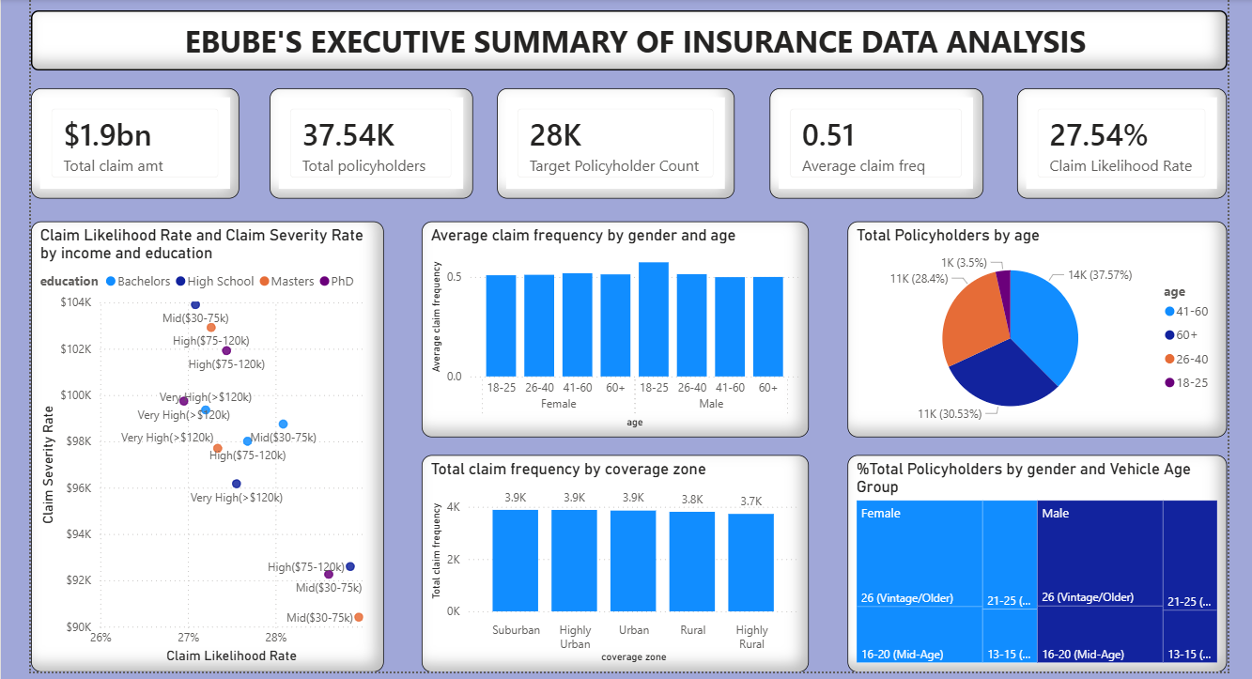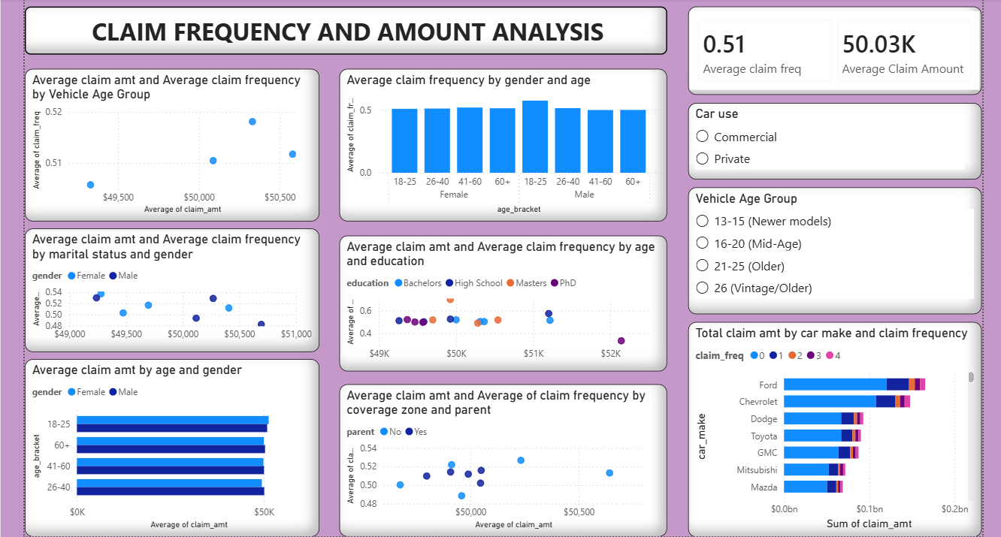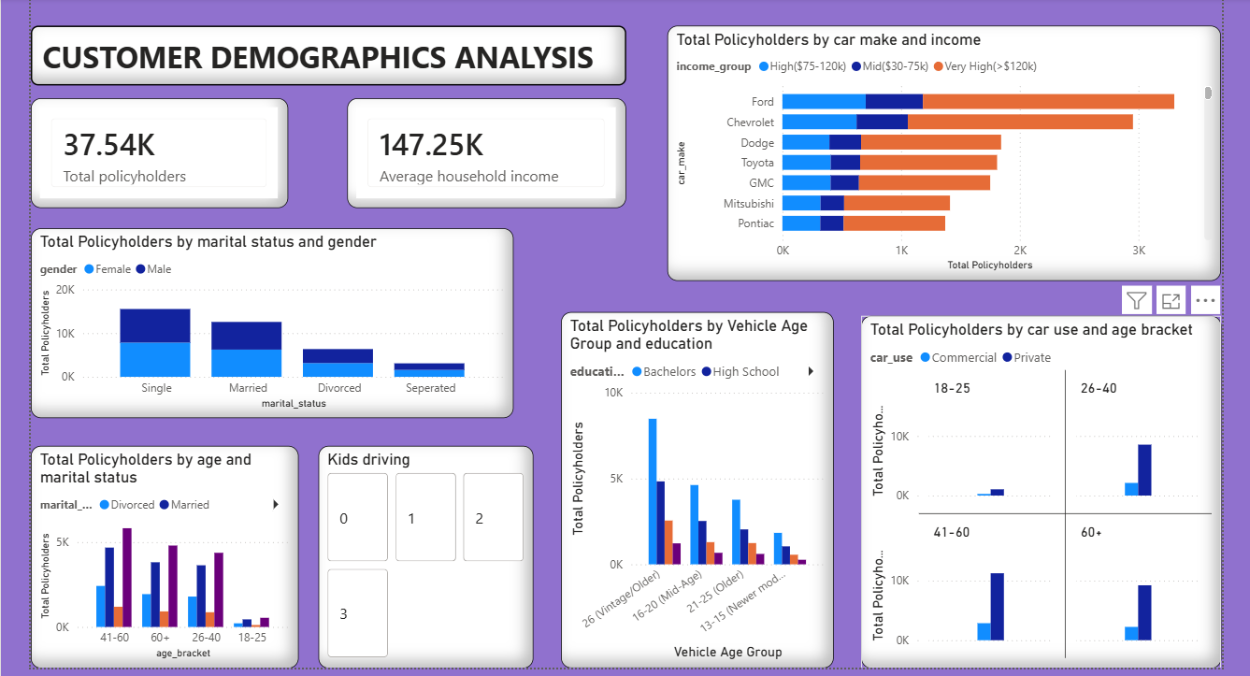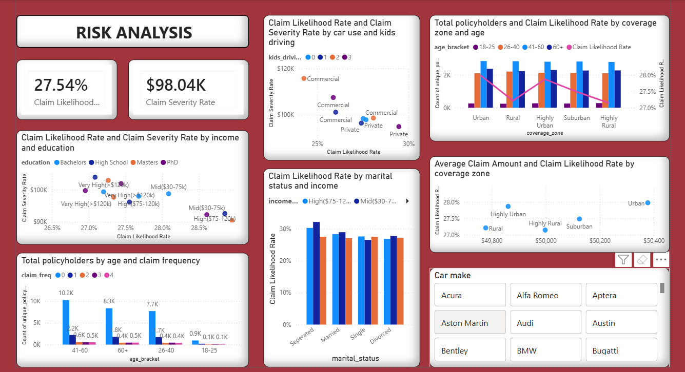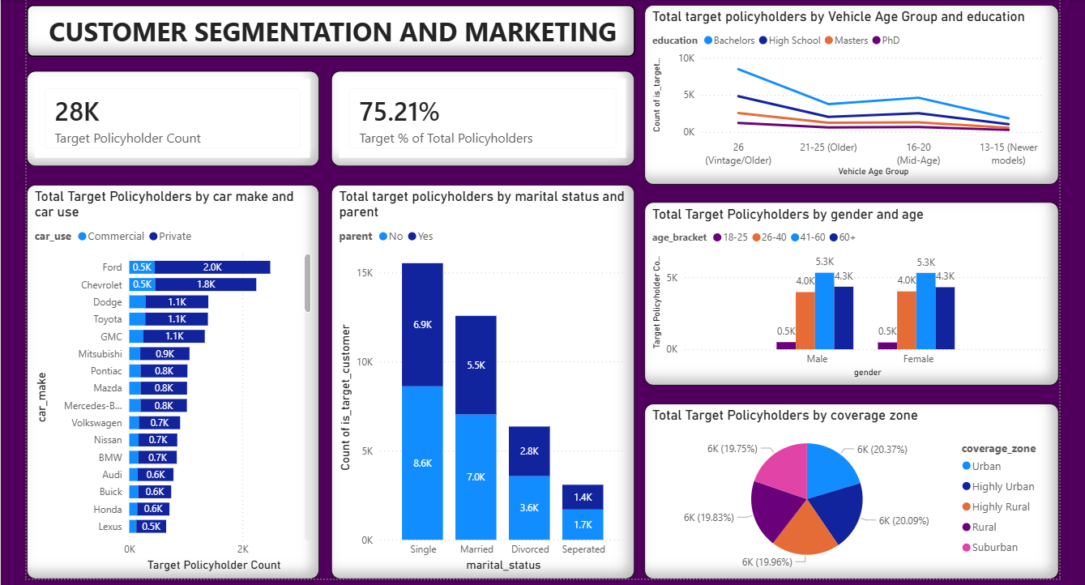

SECTION 3: DETAILED FINDINGS & ANSWERS TO PROJECT BRIEF
1. Claim Frequency and Amount Analysis
- Average Claims across Demographic Groups:
  - Age & Gender: Average claim frequency remains remarkably stable across genders and age groups (~0.50–0.52). However, males aged 18–25 show a slight spike in average claim frequency (~0.54). Average claim amounts hover around $50K across all age brackets.
  - Marital Status: Single and divorced policyholders show slightly higher average claim frequencies compared to married individuals.
- Vehicle Characteristics vs. Claim Correlations:
  - Car Make: Ford and Chevrolet lead in total claim payout amounts (~$0.15bn–$0.20bn combined), primarily driven by sheer volume of policyholders driving these makes.
  - Vehicle Age: Policyholders with vehicles aged 21–25 years (Older) experience higher average claim frequencies (~0.518) compared to newer vehicle brackets (~0.505).

2. Risk Assessment
- High-Risk Policyholder Indicators:
  - Income & Education: Policyholders in the Mid ($30–75k) income tier holding High School education exhibit higher Claim Likelihood Rates (~28.2%) and severe Claim Severity Rates (~$104K per claim). Conversely, Very High (>$120k) income holders with PhDs exhibit lower likelihood rates (~27.0%).
  - Coverage Zone: Highly Urban and Urban zones carry higher claim likelihood rates (~28.0%) compared to Rural zones (~27.0%).
  - Marital Status & Income: Separated Policyholders in the Mid($30-75k) income tier have a significantly more Claim Likelihood rate (32.13%).
  - Commercial Youth Drivers: The single highest severity risk ($110K+ per claim event) occurs when policyholders utilize vehicles for Commercial purposes with 1 or 2 children driving.

3. Customer Segmentation & Marketing
- High-Value / Low-Risk Profile (Target Segment):
  - Segment Definition: Household Income > $75K and ≤ 1 claim.
  - Size: 28K policyholders representing 75.21% of the entire customer base.
  - Key Demographics: Dominated by single policyholders (15.5K total, split 8.6K non-parents / 6.9K parents) and married policyholders (12.5K). Age groups 41–60 and 60+ make up the largest share (5.3K each). Evenly distributed across all coverage zones (~19.7% to 20.4% per zone).
  - Vehicle Choices: Primarily driving private vehicles, with Ford (2.5K), Chevrolet (2.3K), and Dodge (1.1K) as top makes. Holders of Bachelor’s degrees driving 26+ year-old vehicles form the largest single sub-segment (10K).

4. Demographic Analysis
- Demographic Variations:
  - Age Distribution: The customer base is heavily skewed toward mid-to-older adults: 41–60 age group represents 37.57% (14K), followed by 60+ at 30.53% (11K), 26–40 at 28.4% (11K), and 18–25 at only 3.5% (1K).
  - Marital Status & Gender: Single policyholders form the largest group (~16K), followed by Married (~12K), Divorced (~6K), and Separated (~3K). Gender distribution is almost perfectly equal (50/50) across all marital states.
- Car Usage and Ownership Trends:
  - Private vs. Commercial: Over 80% of policyholders across all age brackets utilize their vehicles exclusively for Private purposes. Commercial usage is slightly higher in the 41–60 age bracket.

5. Geographic & Behavioural Insights
- Regional Trends Across Coverage Zones:
  - Claim Volume: Total claim frequency is evenly distributed across all 5 zones (~3.7K to 3.9K claims per zone).
  - Risk & Payout Variance: Urban and Highly Urban zones show higher claim likelihood rates (28.0% and 27.8% respectively) and slightly higher average claim amounts (~$50.4K) compared to Rural zones (~27.2% likelihood, ~$49.8K average).
  - Customer Distribution: Customers are evenly distributed across all the geographic zones.

6. Customer Behavior Insights (Kids Driving)
- Impact of Teen/Child Drivers:
  - Claim Severity: Policyholders with 1 or 2 kids driving utilizing cars for Commercial purposes experience the highest claim severity rates ($110K+ per claim event).
  - Private Use Stability: For Private car usage, the presence of kids driving causes only minor fluctuations in claim likelihood (hovering between 27% and 28.5%).

SECTION 3: STRATEGIC RECOMMENDATIONS
1. Underwriting Adjustments: Implement a premium surcharge on commercial policies that include young/child drivers.
2. Urban Pricing Surcharge: Introduce a 2–3% risk adjustment premium for policyholders located in Urban and Highly Urban coverage zones.
3. Underwriting Takeaway: Premiums in Urban/Highly Urban zones should carry a slight risk surcharge to account for higher claim probabilities

SECTION 4: TARGETED MARKETING
1. Retention Campaigns: Launch targeted marketing initiatives focused on the 28K high-income, low-claim customer base, specifically targeting the following:
- Mature drivers (41–60+) driving private vehicles with household income >$75k
- None parents who are of single and married marital status
- Ford, Chevrolet, Dodge, Toyota and GMC car make owners as they have the highest volume in the High Value demographic.
- Vintage and Mid Age car owners.
- Very High (>$120k) income holders with PhDs as they exhibit lower claim likelihood rates (~27.0%).

2.Equal geographical distribution (~19.7% to 20.4% across all 5 zones) indicates digital campaigns can be deployed uniformly across regions rather than restricted to specific coverage zones.

